ASS 8
- Write a program that will ask the user to input a decimal integer number and then print the number out in hexidecimal and octal format.
Your program should look something like this:
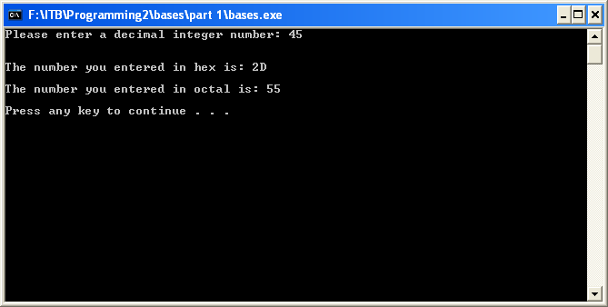
- Modify your program so that the user can choose which output format to use - hex or octal.
Your program should look something like this:
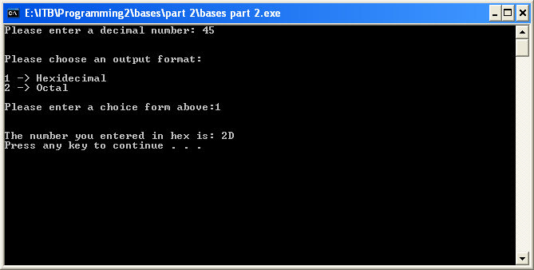
- Modify your code once more such that you now ask the user for an input format andan output format.
Your program should look something like this:
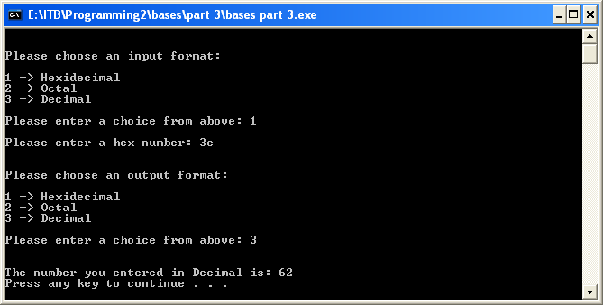
Upload your source (".c") file below.

ASS 10
Write a program that asks the user to input 5 real numbers.
- Store the numbers in floats.
- Print out each number to 2 decimal places in a neat table where the decimal points line up above each other.
- You should be able to enter numbers with any number of digits before and after the decimal point and still get a nice neat table.
What is the biggest and smallest numbers you can enter? Can you use code to find this out? If so print a message at the beginning of the program warning the user of the max and min values.

Ass 11
Write a program that uses the C preprocessor to define 7 constants - one for each day of the week e.g.
- MONDAY should be defined to be 1
- TUESDAY should be defined to be 2
- etc
Your program should ask the user to input a number between 1 and 7 and then print a message saying what day of the week this corresponds to.
You should use code like this:
if(inputNumber == MONDAY)
{
printf("Monday\n");
}
Extra credit:
Make sure your program only lets the user enter numbers between 1 and 7. If the user enters a number less than 1 or bigger than 7 print an error message and end the program.

